**Computational Photography and Image Manipulation**

**Programming Assignment 1**

**Report**

**Method1:**

Random sampling is achieved by randomly selecting coordinates, directly intercepting the coordinates + patch size patch, and pasting it onto a new image.

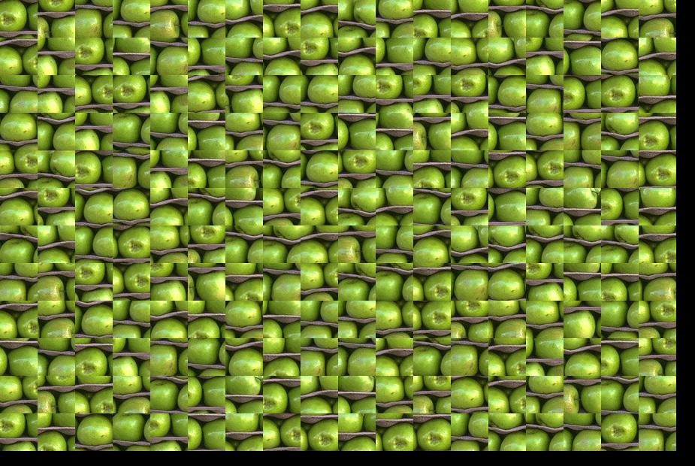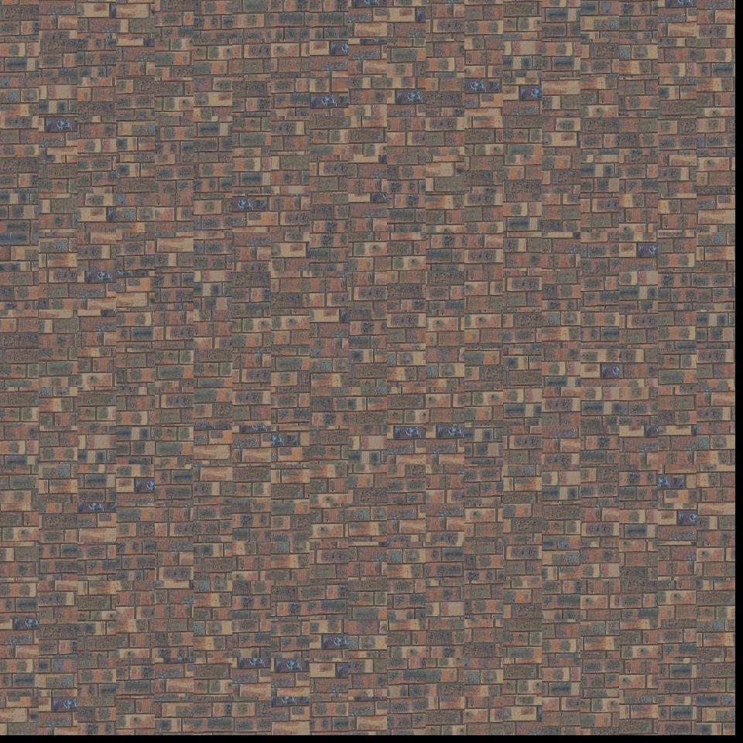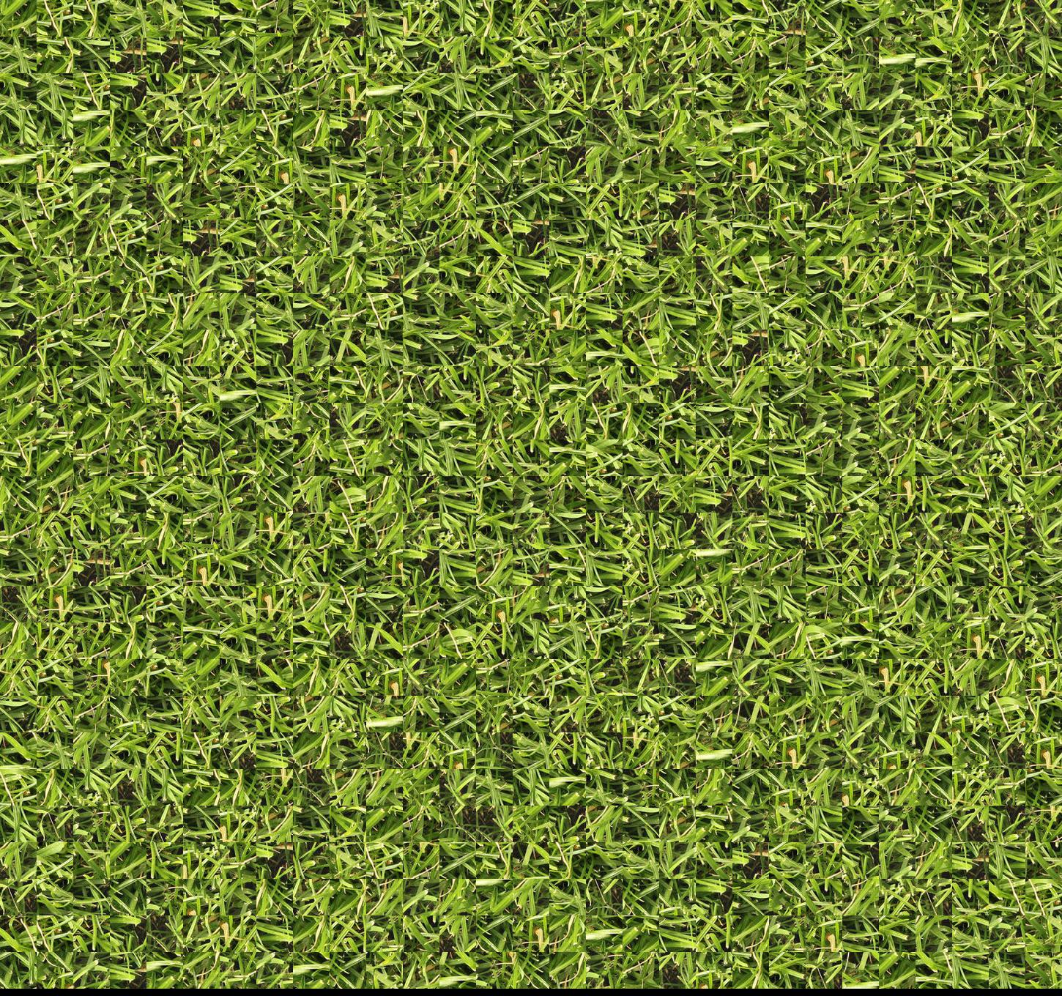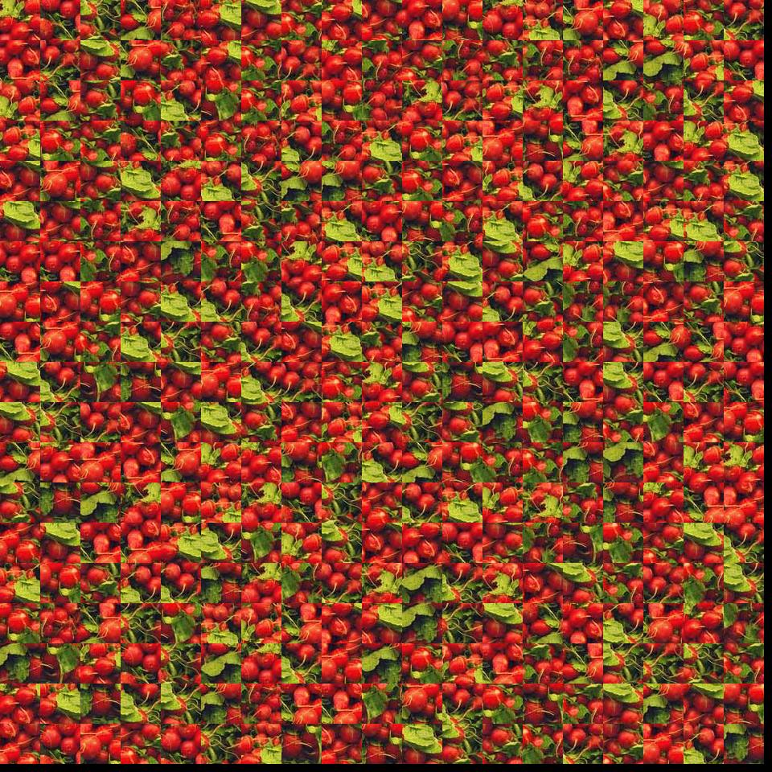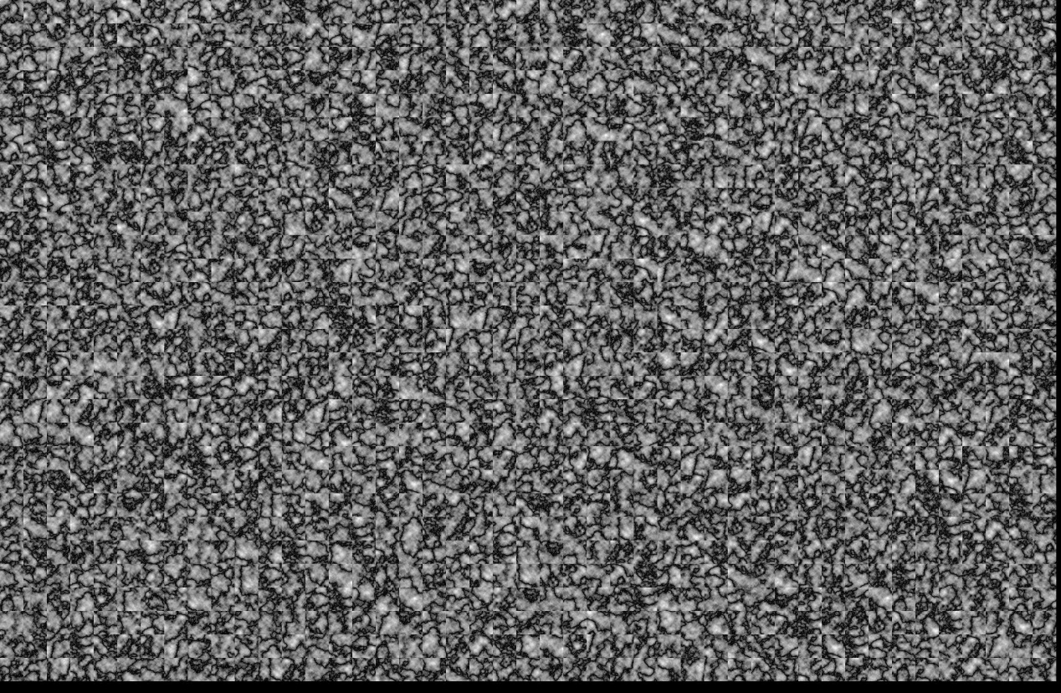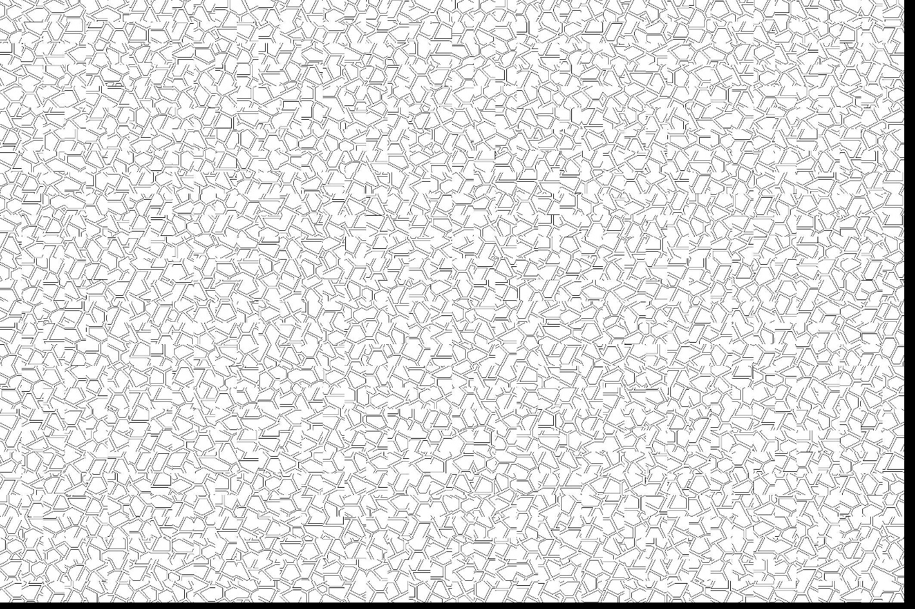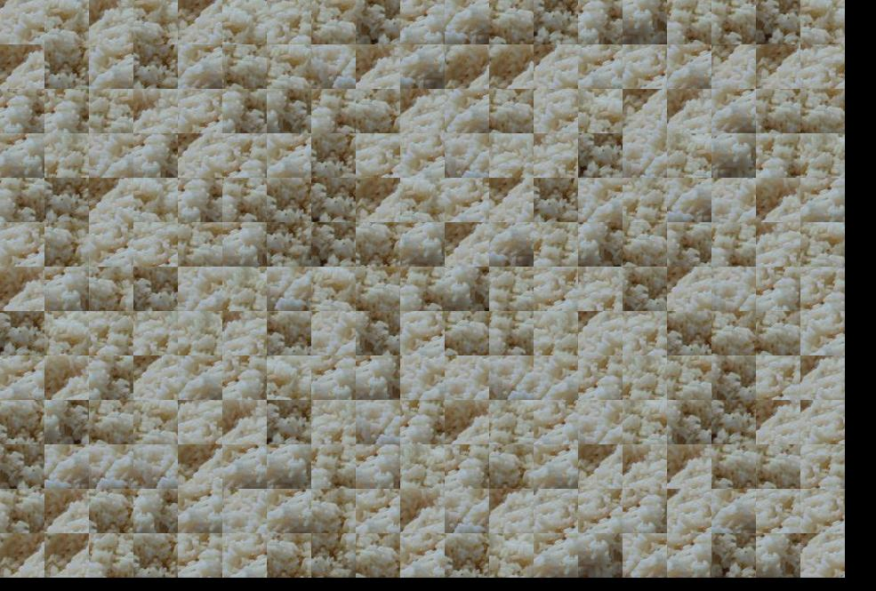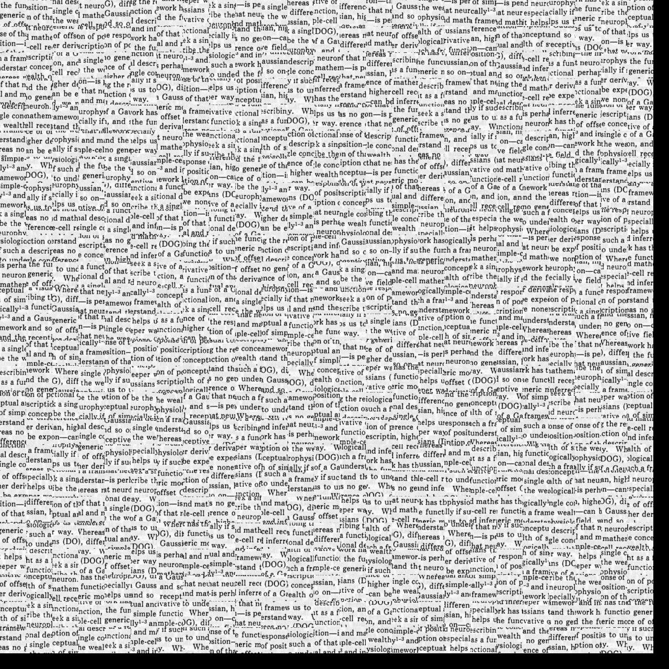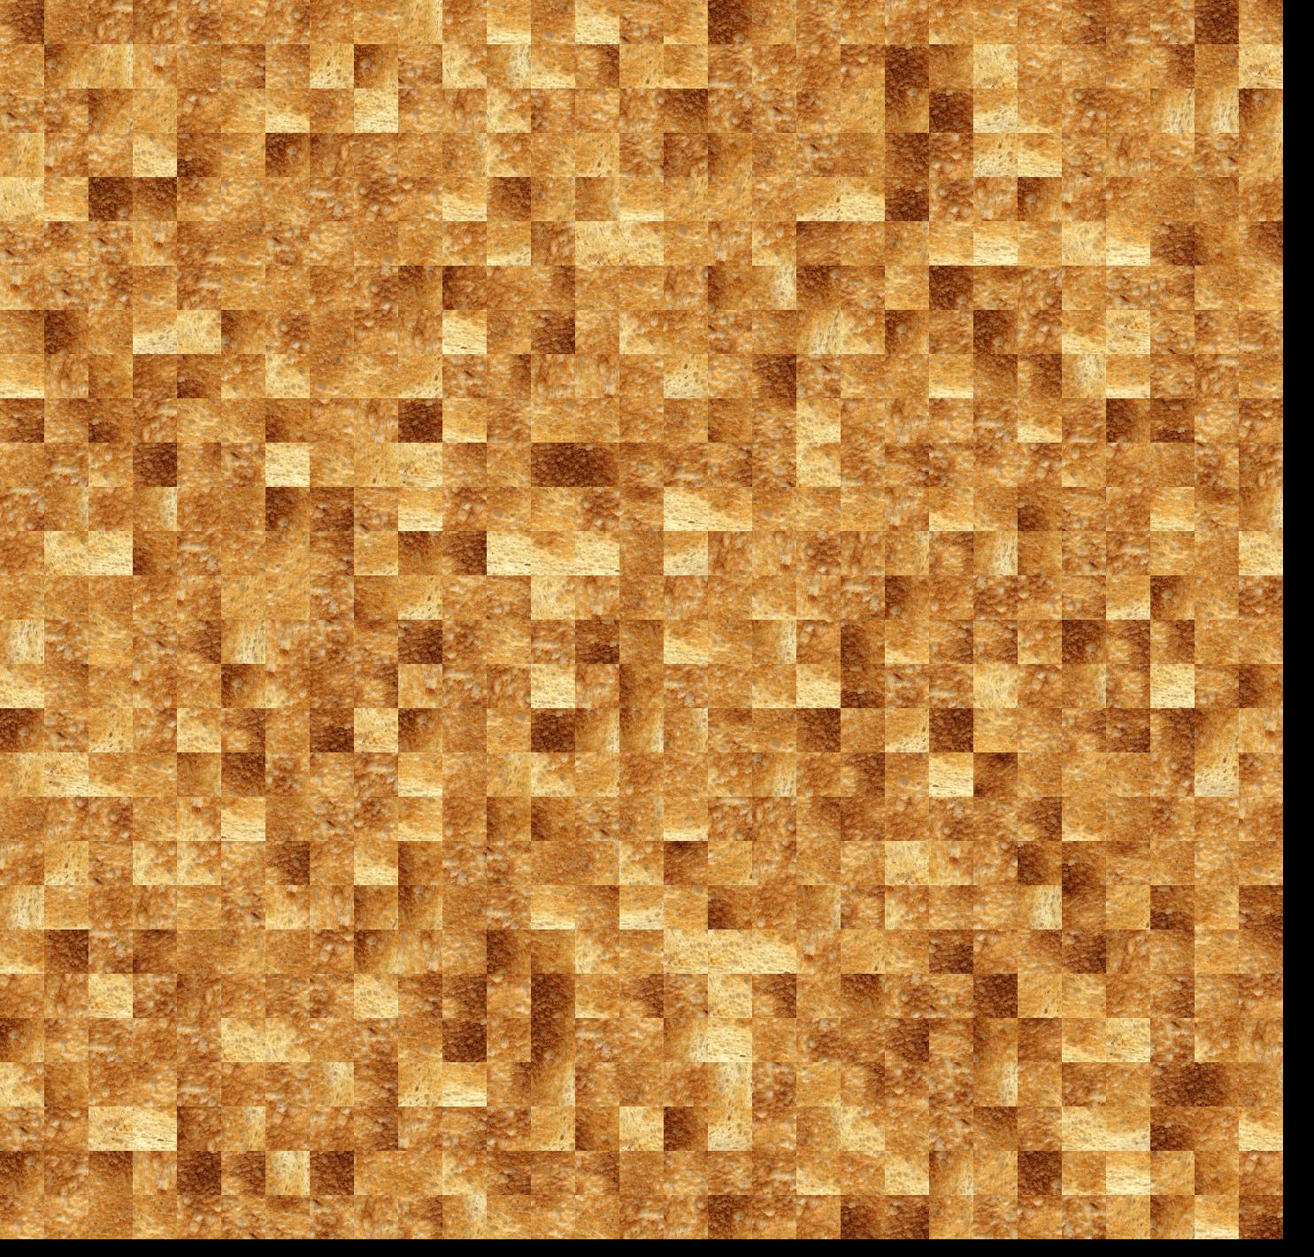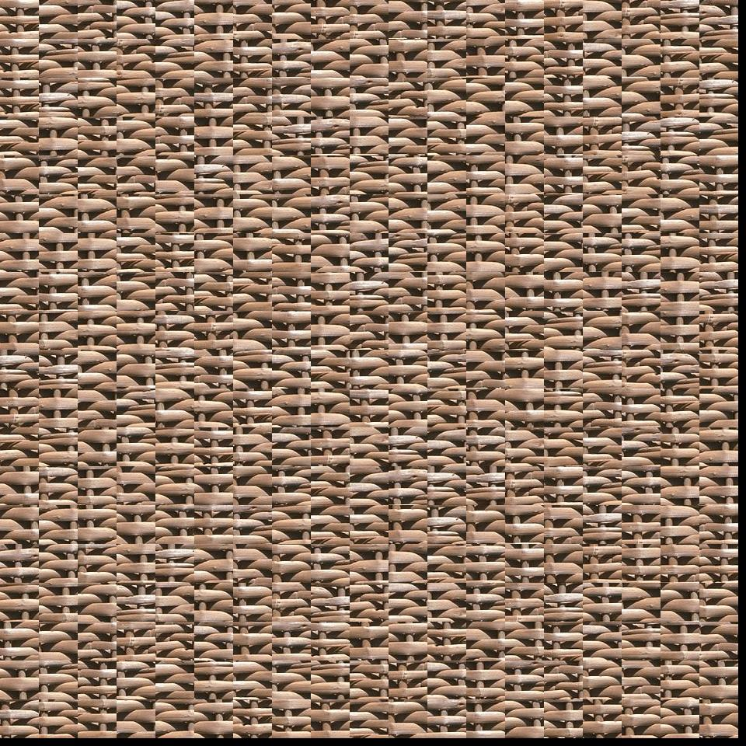

**Method 2**

First calculate the first point random map, and then the map after that only look at the overlap region above and to the left, for the calculation of SSD, you can greatly improve the efficiency of the calculation, will be the next map pasted to the right or below the previous map, the overlap region for the cover up.

But unfortunately, in that algorithm I didn't finish the final debug